DROPPED KNITS Go to http://www.phillyknits.org/Learn2Knit.htm for more print & video instructions!
 | Read from left to right >
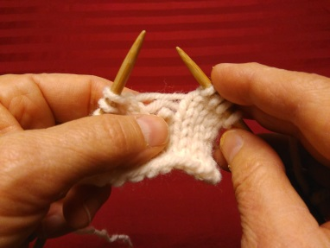 | 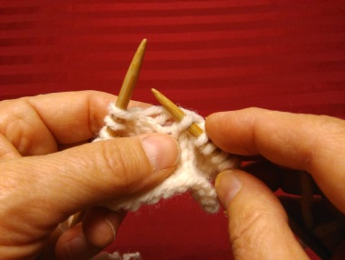 | 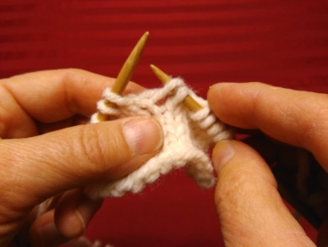
Put unstitched yarn behind dropped knit.> | Insert needle in both dropped knit > | … & under 1st unknit yarn.
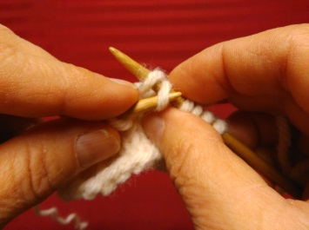 | 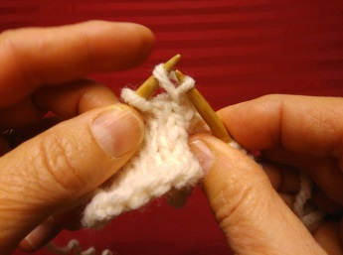 | 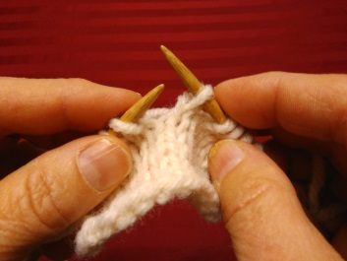
Insert left needle into dropped knit > | …and lift over yarn, as in binding off. > | Repeat process for 2nd unknit yarn.
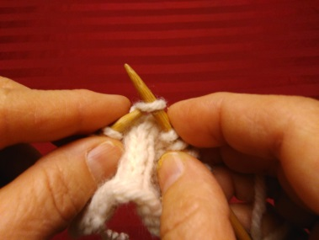 | 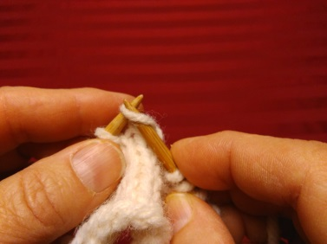 | 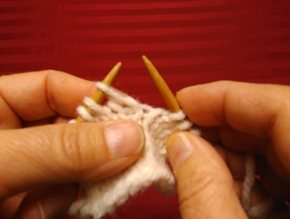
Lastly, put left needle under fixed knit > | …slipping it over to the left needle. > | Dropped knit is ready to be knit or purled!

DROPPED PURLS
 | Read from left to right >
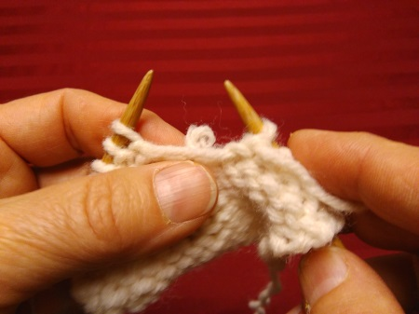 | 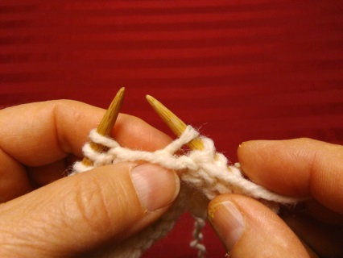 | 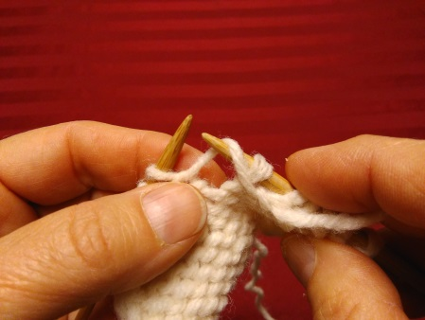
Put unstitched yarn in front dropped purl. > | Insert needle in both dropped purl… > | & under unstitched yarn.
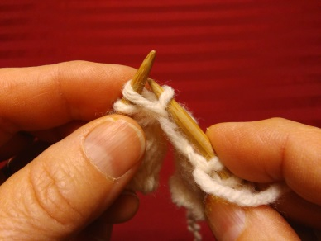 | 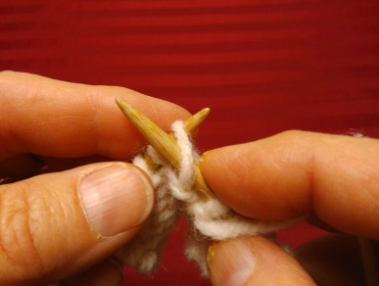 | 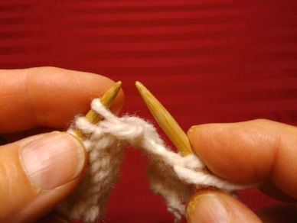
Lift dropped purl over yarn, as in bind off. > | Put left needle behind purl, slip from > | …right to left needle. Repair complete!
Tips: Both dropped knits and purls can be easily recovered, as demonstrated above, when everything above the dropped stitch is either a knit or a purl. However, if the stitch types vary (above the dropped stitch), then you must physically place the unstitched yarn in front of dropped purls in order to properly restore them.

