PhillyKnits.org
BIND OFF
Ditty: Knit two knits, lift 1st over 2nd, knit another one, repeat & repeat, until the row is done!
 | read from left to right >
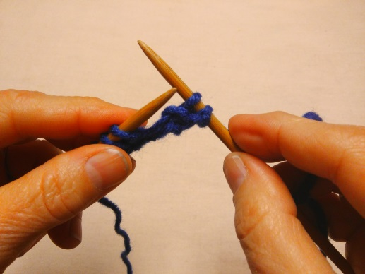 | 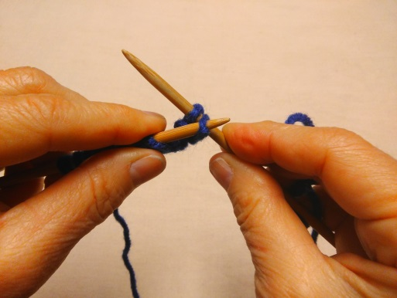 | 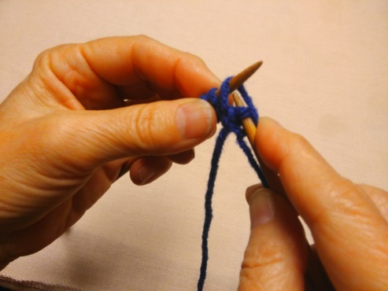
Knit 2 stitches. > | Insert needles under first loop… > | …and lift over second loop…
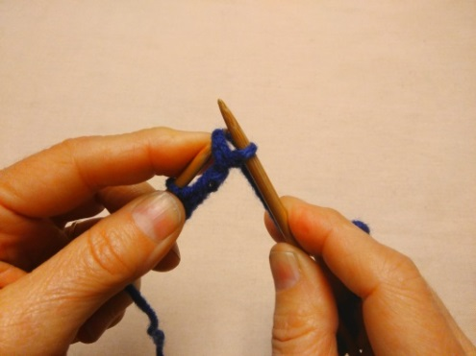 | 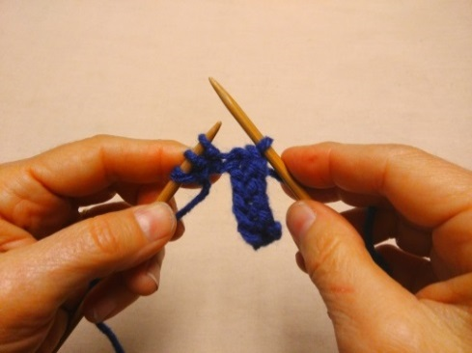 | 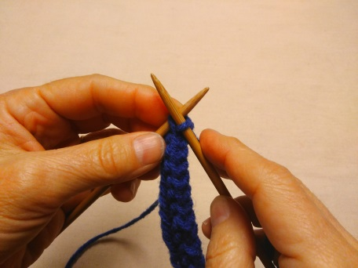
…and off the needle. > | Knit another stitch & repeat process… > | …until the last loop, then…
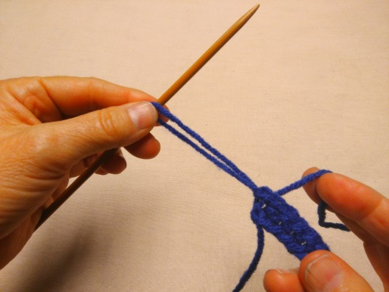 | 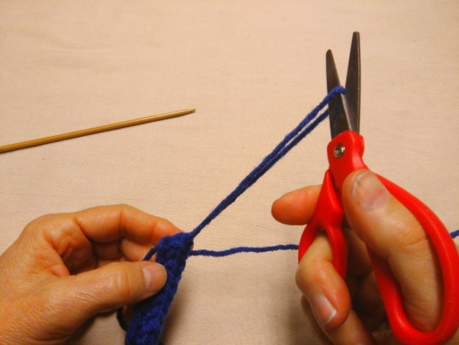 | 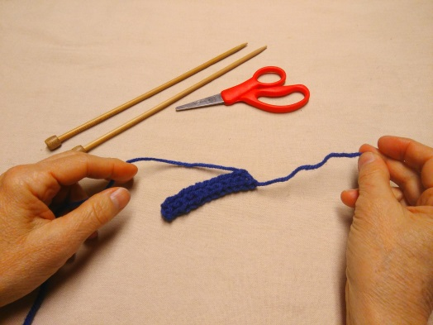
…pull yarn out, using needle… > | … and cut. > | A brief example of binding off.

TIP: No more than two stiches on the right-hand needle at any given time.

Go to http://www.phillyknits.org/Learn2Knit.htm for more print & video instructions!

