KNIT - When you knit on one side, you create a purl on the other side. PhillyKnits.org
Ditty: In front door, cross out back, between down & up again, then off jumps Jack!
 | read from left to right >
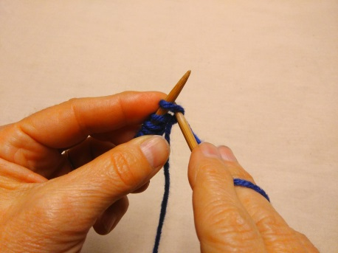 | 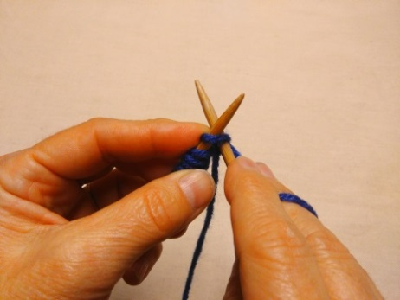 | 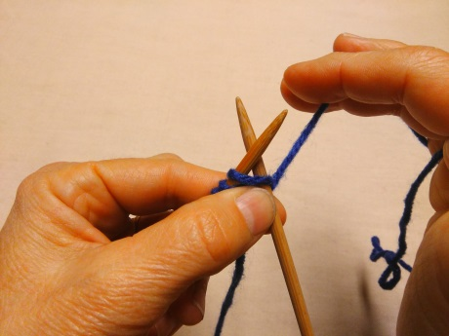
With ball yarn in the back,  insert right needle under first loop… > | …moving needle in the front of loop,  then across the back. > | Hold both needles under the yarn loop with first finger & thumb.
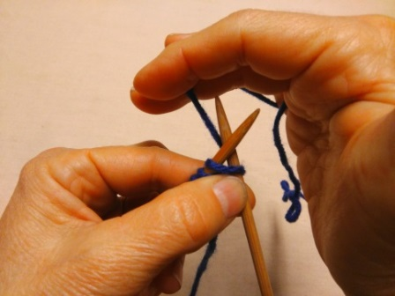 | 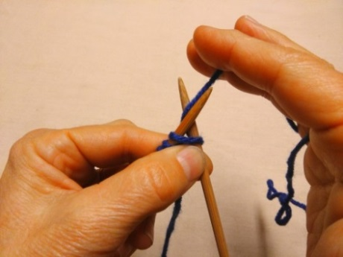 | 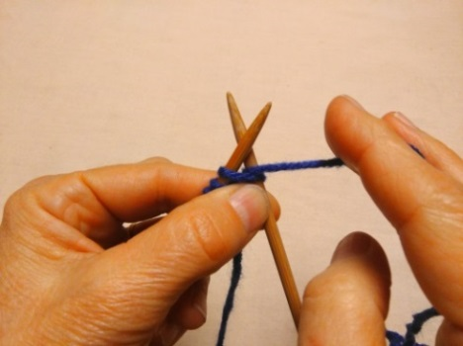
Wrap yarn in back and around… > | …then between both needles. > | To maintain needed tension in yarn…
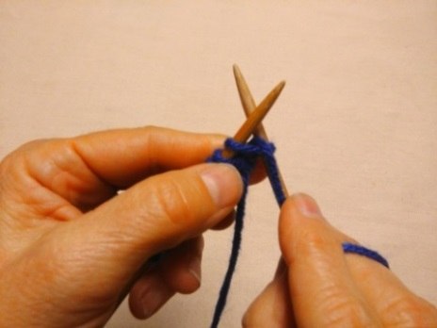 | 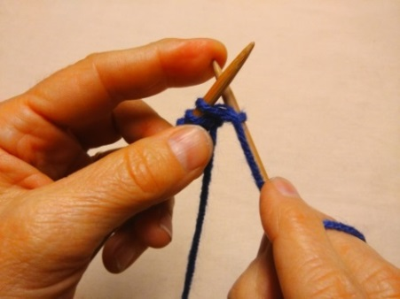 | 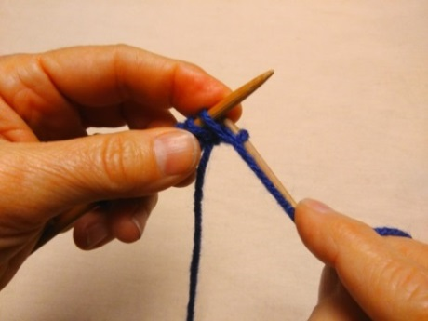
…hold yarn down with first finger. > | Push needle down… > | … & tilt it under the other needle,
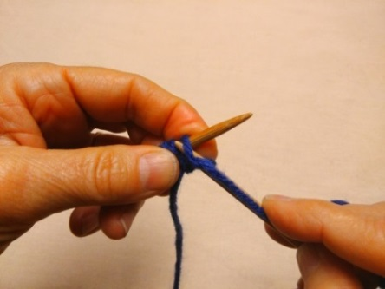 | 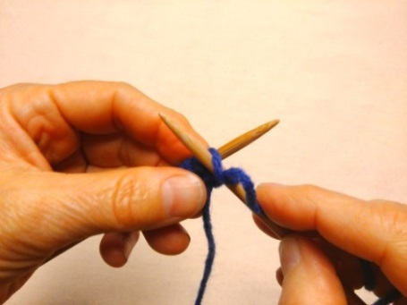 | 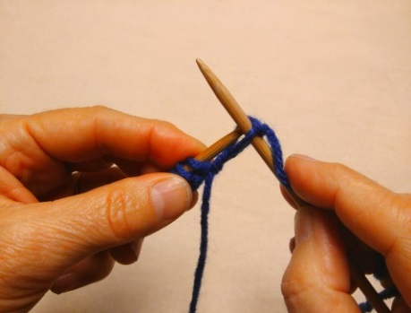
…then push it up again on other side. > | Start to push the loop… > | …off of the needle,
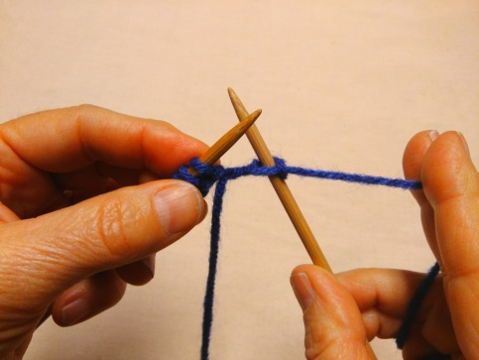 | 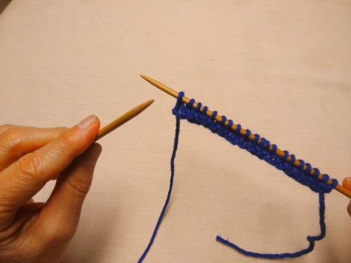 | 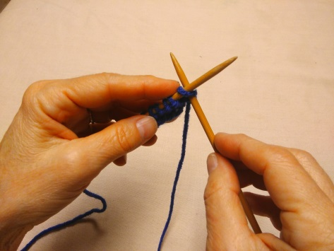
then firm up the knit, but not too tight! | Repeat process until row is finished... | …then switch hands and start a new row!
Go to http://www.phillyknits.org/Learn2Knit.htm for more print & video instructions!

