INCREASE Source: http://www.learn2knit.co.uk/knitting/increasing.php
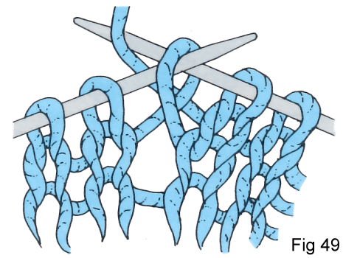 | 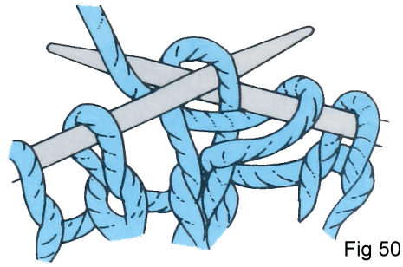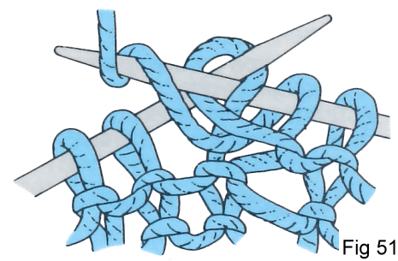 | 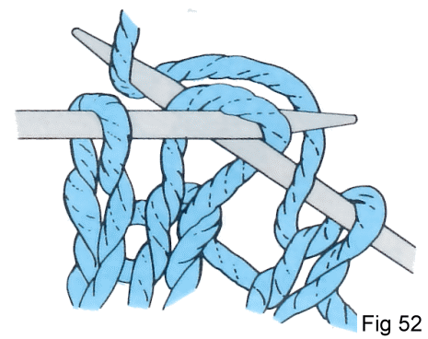  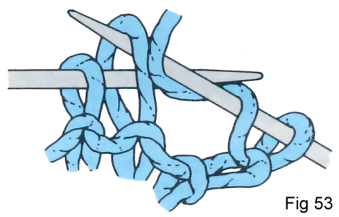
Make 1 (M1) Lift the yarn lying between the stitch just worked and the next stitch and place it on the left hand needle, then knit (or purl) into the back of this loop (Fig.49). To make two stitches (M2) work as for M1 but knit into the back and then the front of the loop. | Working into the front and back of a stitch (inc 1 or inc in next st)  On a knit row, knit first into the front of the stitch normally, then, before slipping it off the needle, knit again into the back of the same stitch (Fig.50), and slip the stitch off. The same method is applied to a purl row, in this case you purl into the front then the back of the stitch (Fig.51). | Yarn forward increase  On a knit row (yf), knit a stitch, bring the yarn to the front, take it over the right hand needle and knit the next stitch (Fig.52). On a purl row (yrn), take the yarn over the right hand needle to the back of the work, then under the needle to the front (Fig.53).

DECREASE Source: http://www.learn2knit.co.uk/knitting/decreasing.php
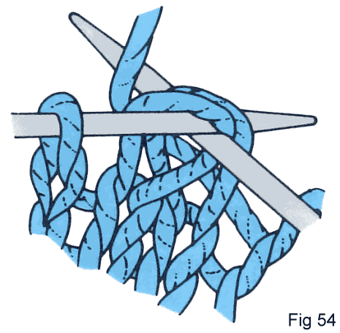 | 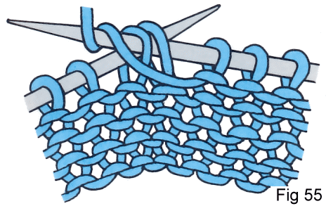 | 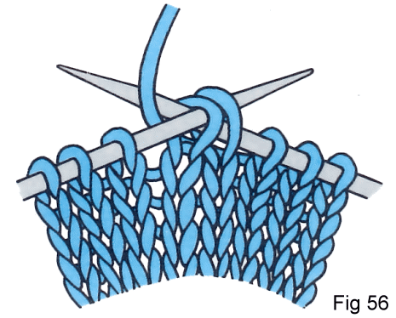
Work two stitches together  On a knit row (k2tog), insert the right hand needle through two stitches instead of one, and then knit them together as one stitch (Fig.54). | On a purl row (p2tog), insert the needle purlwise through the two stitches and purl in the usual way (Fig.55). | Work two stitches together through back of loop  On a knit row (k2tog tbl), insert the right hand needle knitwise through the back of the loops of the next two stitches on the left hand needle and knit them as if they were one (Fig.56)
SLIP STITCH Source: https://www.anniescatalog.com/knit/content.html?content_id=163&type_id=S&scat_id=343
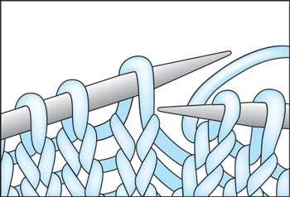 | 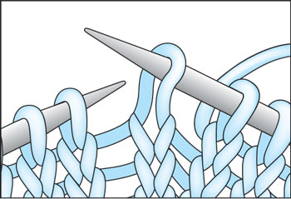 | Insert the tip of the right knitting needle in the next stitch on the left knitting needle from back to front as if to purl. Slide the stitch off the left knitting needle onto the right knitting needle.
Slip stitches "purlwise" by inserting needle as if to purl, but instead, transfer stitch from left to right needle.
Slip stitches "knitwise" by inserting needle as if to knit, but instead, transfer stitch from left to right needle.
Go to http://www.phillyknits.org/Learn2Knit.htm for more print & video instructions.

