PhillyKnits.org
SLIP KNOT
Ditty: Wrap & cross, hold down with thumb, under & over, it’s a slipknot you’ve done!
 | read from left to right >
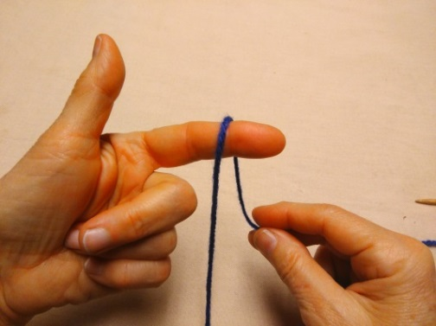 | 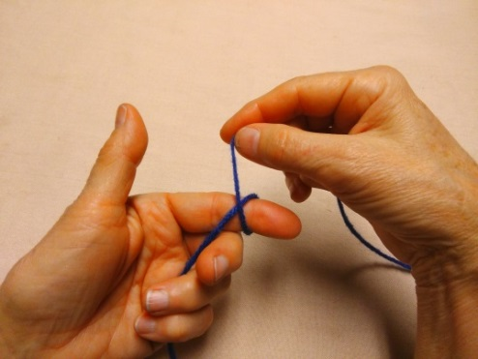 | 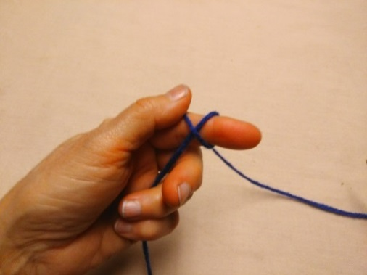
Wrap yarn on finger from front to back. > | Bring yarn up and cross it over itself. > | Hold the yarn down with thumb.
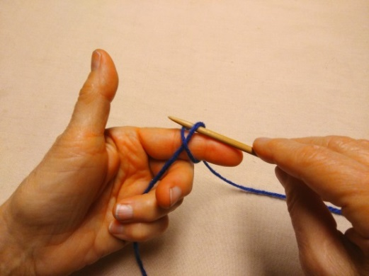 | 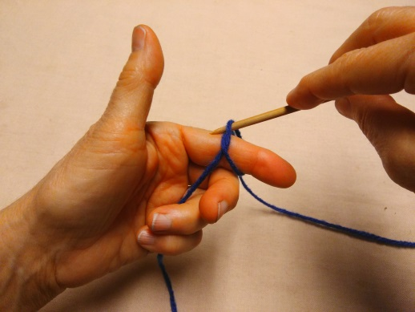 | 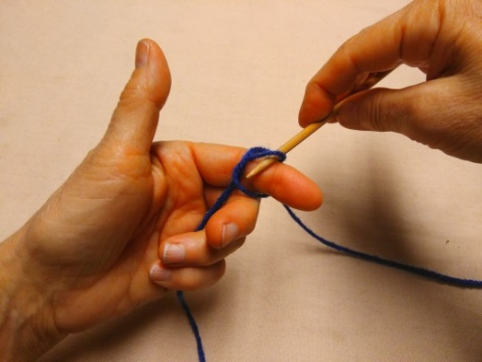
Place needle under the first yarn and over the second… > | …using needle, drag second yarn… > | …under first yarn.
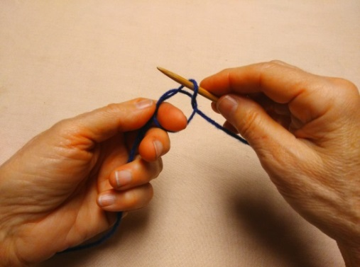 | 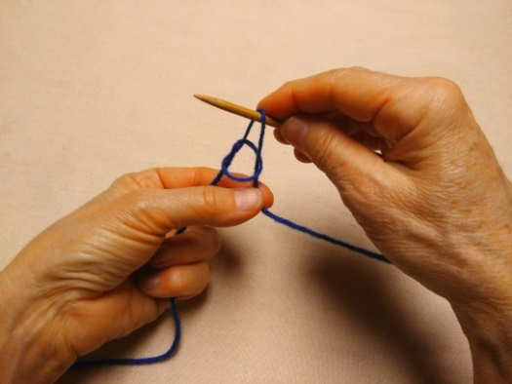 | 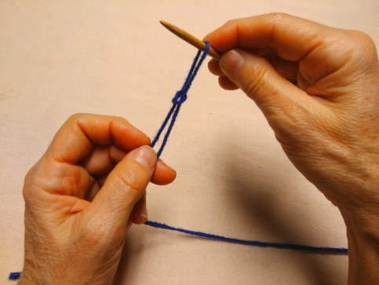
Remove your finger… > | …and collect both yarns. > | Holding both strands of yarn with one hand, pull up the loop with needle…
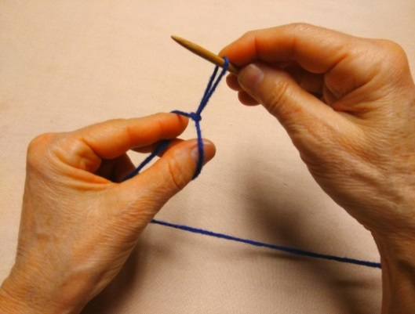 | 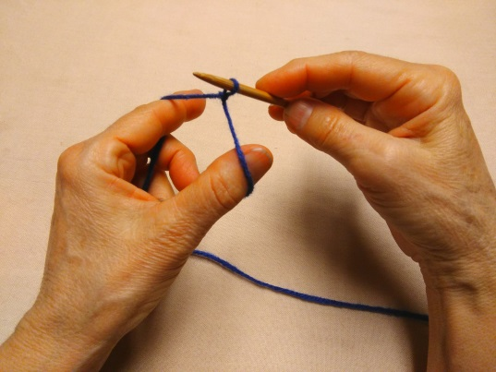
… and insert thumb & first finger under loop… > | …spreading thumb and finger to gently tighten, but not too tight!
Go to http://www.phillyknits.org/Learn2Knit.htm for more print & video instructions!

