LEARN TO KNIT!
PhillyKnits.org
Knitting is good for the brain. It also teaches patience, persistence, & self-reliance, plus it can be very relaxing & meditative. Teaching others to knit is goodness itself, and helps to advance and solidify one’s own skills. Lynn Landes
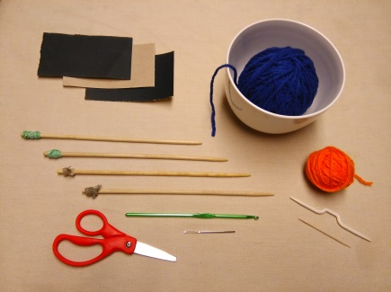

KNIT KIT! What you need to get started:

• yarn: 2 balls (small Practice Ball - 7” around), plus Project Ball, solid color and medium weight (worsted / # 4) is recommended for beginners (later, use multicolored yarns to better hide mistakes, stains, holes from moths, etc.)
• knitting needles: 2 pairs for Project & Practice, use short 9-inch long needle, size 8, wood is best, plastic next, metal can be too slippery for beginners,
• sandpaper (220, 320, & 600) for Homemade Knitting Needles (see directions below)
• cable needle or round (not square) toothpick
• tapestry / jumbo needle, or make your own using rounded toothpicks or mini bamboo 8” skewers (see directions below)
• crochet hook (optional)
• small scissors
• bag: any kind of bag to hold your knitting, yarn ball, and supplies
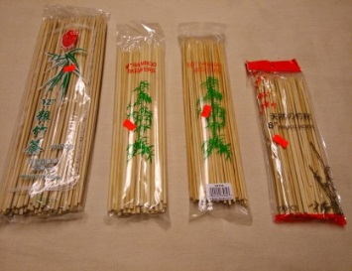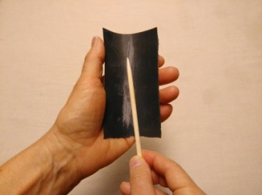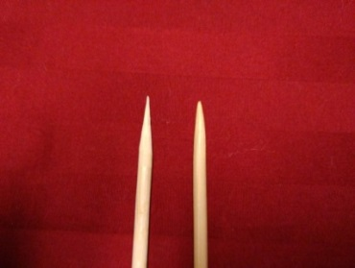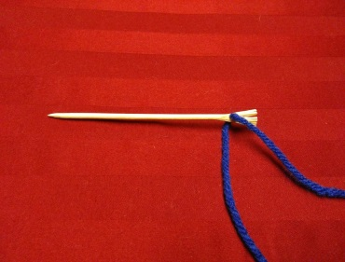

Homemade knitting needles and tapestry “jumbo” needles:

- knitting needles: purchase inexpensive bamboo chopsticks (sharpen in a pencil sharpener) or 10” bamboo skewers (size 8 & already sharpened at one end) available for purchase online, craft stores, and Asian food markets (different lengths and widths could be available). Or purchase dowels at hardware stores or craft stores, and saw to desired length.
- sand entire needle 3 times with 3 grades of sandpaper in this order: 220, 320, then 600 - slightly round off sharpened tip.
- wrap blunt end with rubber band to avoid knitted yarn from following off the needle end. 3rd photo: left needle – unsanded skewer / right needle – finished “skewered” knitting needle!
- tapestry /jumbo needles – purchase rounded toothpicks or 8” mini bamboo skewers (size 3), cut in half, hammer blunt end in order to wedge yarn into wood fibers, then sand pointed end as above. For a second jumbo needle from other half of skewer, sand one end to a point (it will take more time since it is a blunt end) and hammer other end as above.
Go to http://www.phillyknits.org/Learn2Knit.htm for more print & video instructions!

