INVISIBLE SEAMING (work on right side of garment) Source: http://www.learn2knit.co.uk/knitting/joining.php
Knit Seam | Knit Seam | Purl Seam
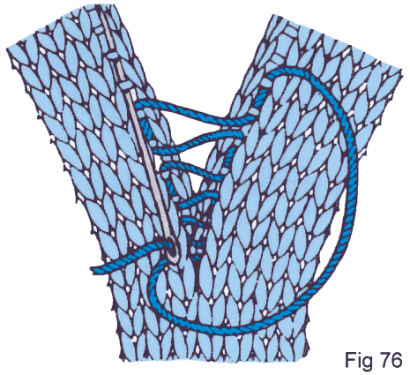 | 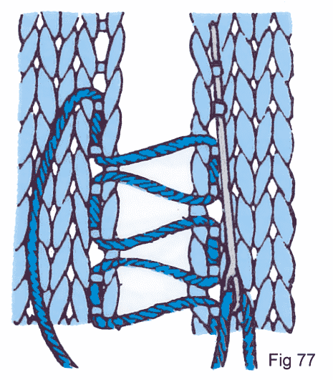 | 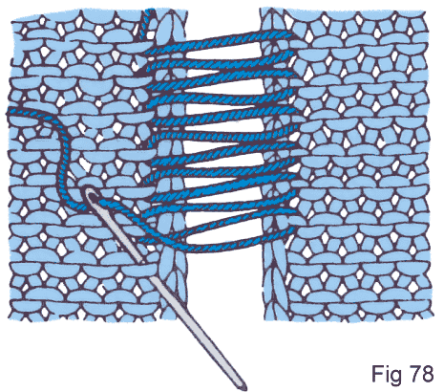
1 knit from edge, 2 knits at a time | ½ knit from edge, 2 knits at a time | 1 purl loop at a time

GRAFTING
Knit Side | Purl Side
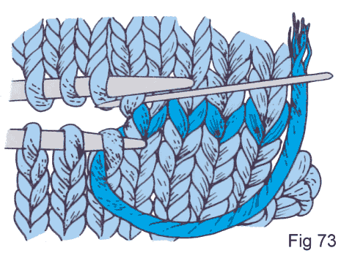 | 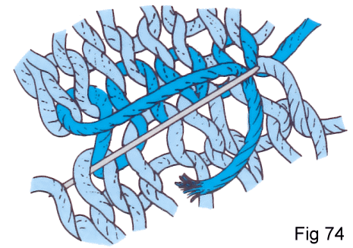

BACKSTITCH SEAMING
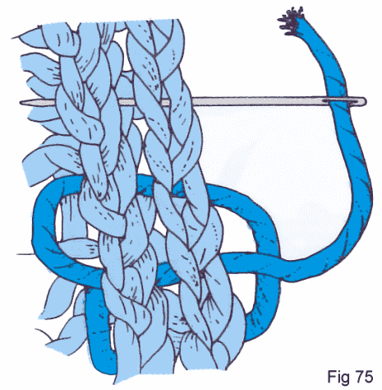
Go to http://www.phillyknits.org/Learn2Knit.htm for more print & video instructions!

