Philly Knits.org!

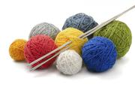
Spreading the Joy of the Fiber Arts!
Philly Knits.org!

Spreading the Joy of the Fiber Arts!

