PhillyKnits.org
CAST ON
Ditty: Outside left, over top right, back thru loop, snug, not tight!
 | read from left to right >
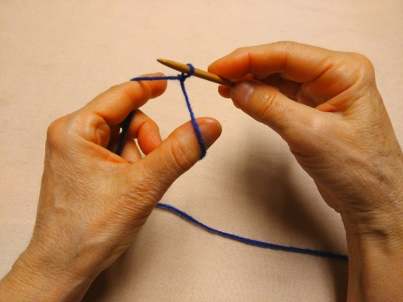 | 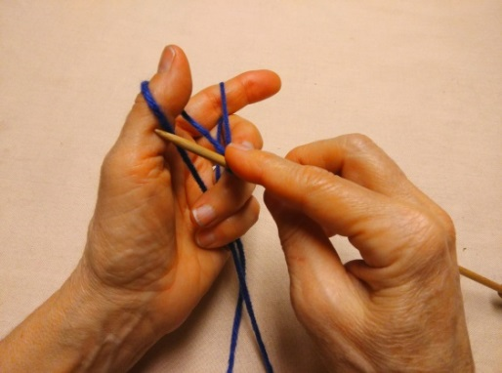 | 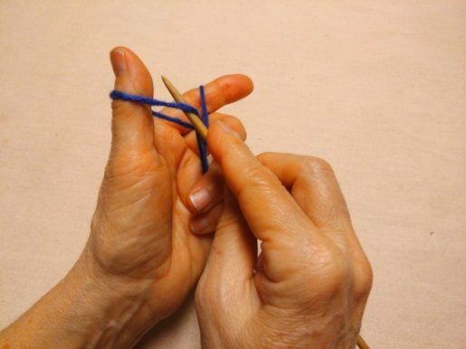
Creat a slip knot. > | Place needle under yarn on left… > | …and move it over to yarn on finger.
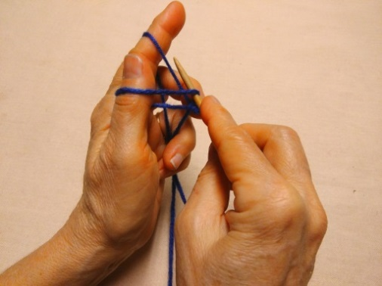 | 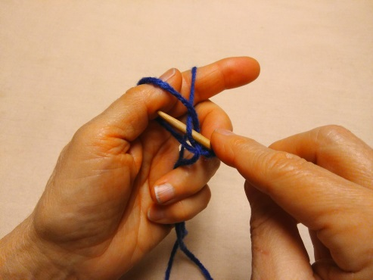 | 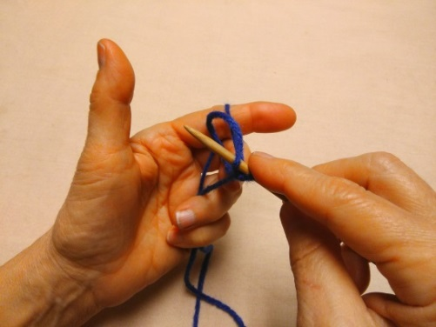
Place needle on top of yarn and … > | … move it through loop under thumb. > | Remove thumb …
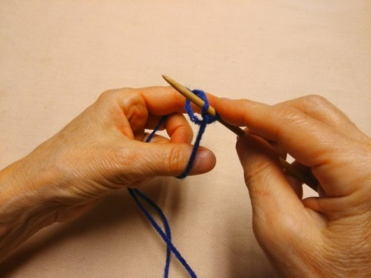 | 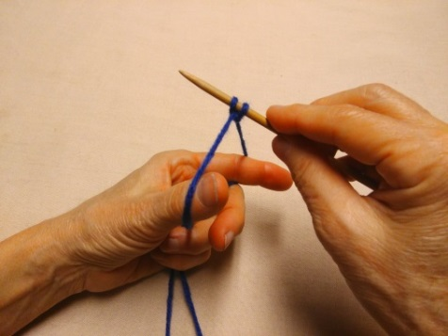 | 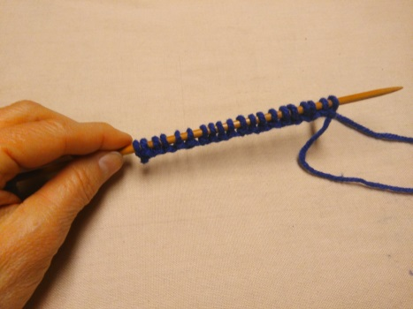
…then re-insert thumb… > | …spread out thumb & finger to tighten.> | Repeat for desired length.

TIPS:
- Stiches should be snug, but not tight. The loops should be able to slide along the needle.
- After casting on, cut tail end of yarn to about 5 inches, so it is not knitted by mistake.

Go to http://www.phillyknits.org/Learn2Knit.htm for more print & video instructions!

