Calling All Yarn Bombers
& Wannabees!

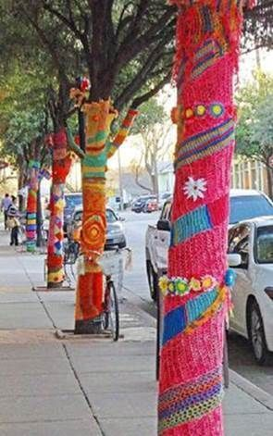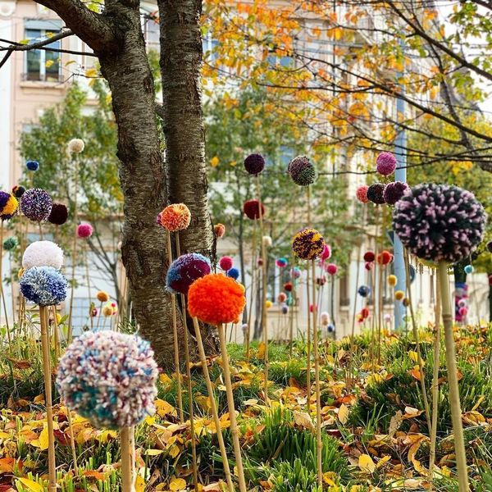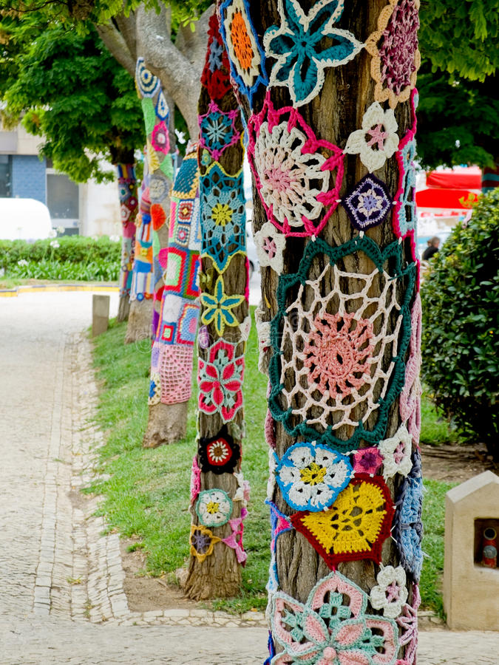

CIANFRANI PARK on March 27, 10-2 pm!
Volunteers needed to help make squares, circles, flowers, pompoms, etc. by March 19th!
This is a community event. Free knitting
& crochet lessons will be given on March 27th!
Go to PhillyKnits.org for more info
or call 714-204-2690!

