PhillyKnits.org
PURL - When you purl on one side, a knit is created on the other side.
Ditty: In back door, cross out front, between down & up again, off Jill jumps!
 | read from left to right >
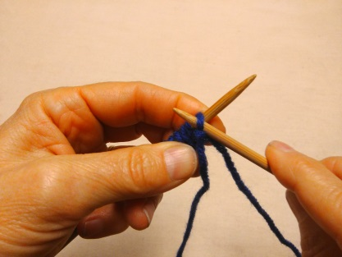 | 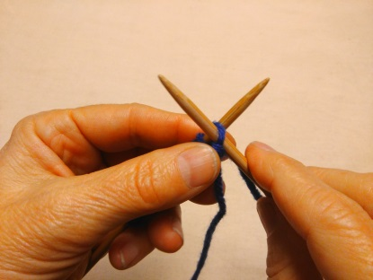 | 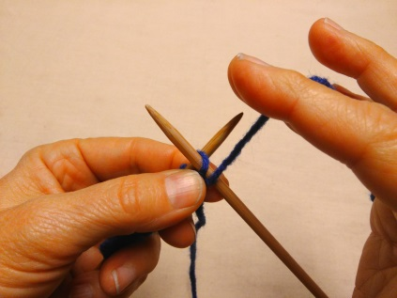
With ball yarn in the front,  insert right needle from above loop… > | …crossing in front of the left needle. > | Wrap yarn between the needles…
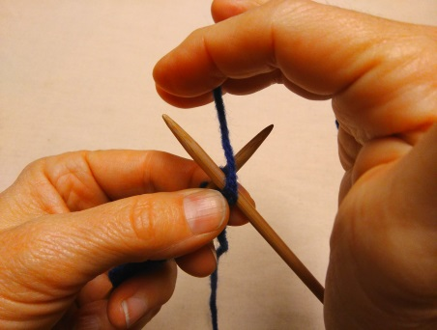 | 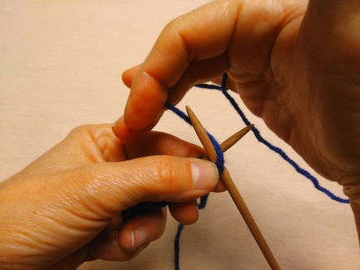 | 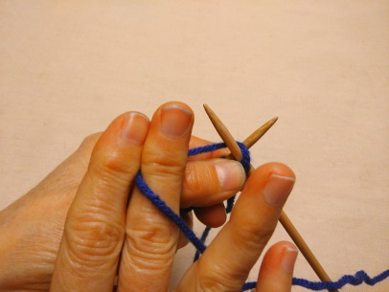
…wrapping around and … > | …moving toward... > | …the front…
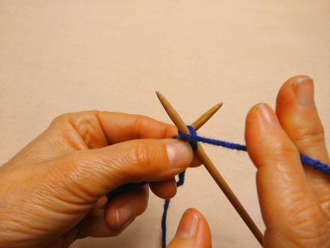 | 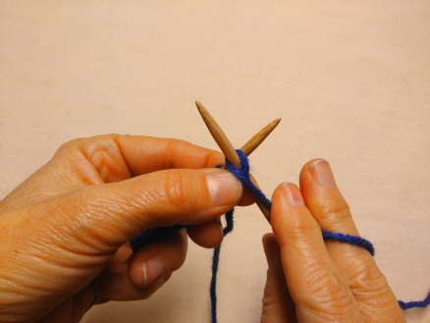 | 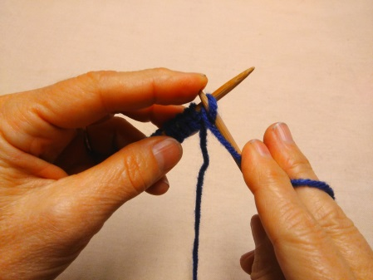
… and side. > | Hold yarn down with 1ST finger. > | Push the needle down with finger…
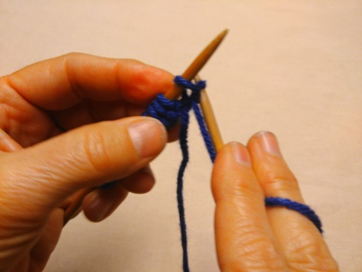 | 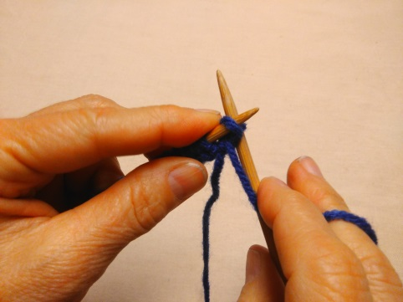 | 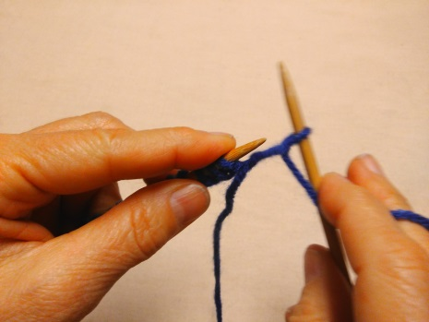
…then tilt needle toward the back &under the other needle. > | Push needle back up on other side & … > | … pull off of the needle to create a purl!

Go to http://www.phillyknits.org/Learn2Knit.htm for more print & video instructions!

